**Branching**

Radha Krishna@LAPTOP-A8SP97KB MINGW64 ~

$ git --version

git version 2.41.0.windows.3

Radha Krishna@LAPTOP-A8SP97KB MINGW64 ~

$ pwd

/c/Users/Radha Krishna

Radha Krishna@LAPTOP-A8SP97KB MINGW64 ~

$ mkdir gittutorial

Radha Krishna@LAPTOP-A8SP97KB MINGW64 ~

$ cd gittutorial

Radha Krishna@LAPTOP-A8SP97KB MINGW64 ~/gittutorial

$ pwd

/c/Users/Radha Krishna/gittutorial

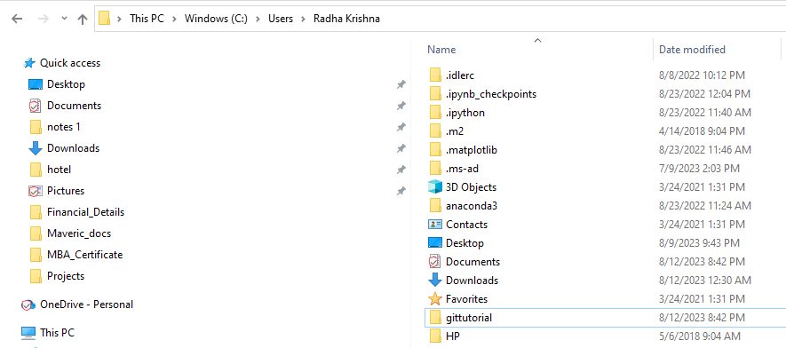

**# Create a text file 🡪Type “Version1”🡪Save it as “hello.txt”**

Radha Krishna@LAPTOP-A8SP97KB MINGW64 ~/gittutorial

$ git init

Initialized empty Git repository in C:/Users/Radha Krishna/gittutorial/.git/

Radha Krishna@LAPTOP-A8SP97KB MINGW64 ~/gittutorial (main)

$ git status

On branch main

No commits yet

Untracked files:

(use "git add <file>..." to include in what will be committed)

hello.txt

nothing added to commit but untracked files present (use "git add" to track)

Radha Krishna@LAPTOP-A8SP97KB MINGW64 ~/gittutorial (main)

$ git add .

Radha Krishna@LAPTOP-A8SP97KB MINGW64 ~/gittutorial (main)

$ git status

On branch main

No commits yet

Changes to be committed:

(use "git rm --cached <file>..." to unstage)

new file: hello.txt

Radha Krishna@LAPTOP-A8SP97KB MINGW64 ~/gittutorial (main)

$ git commit -m "Version1 Commited"

[main (root-commit) 136267a] Version1 Commited

1 file changed, 3 insertions(+)

create mode 100644 hello.txt

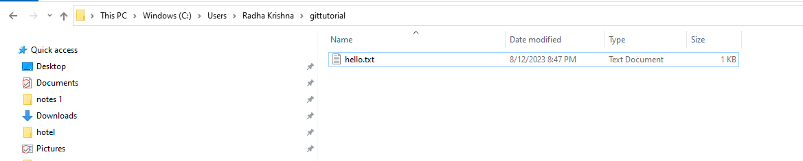

Radha Krishna@LAPTOP-A8SP97KB MINGW64 ~/gittutorial (main)

$ git status

On branch main

Untracked files:

(use "git add <file>..." to include in what will be committed)

hello2.txt

nothing added to commit but untracked files present (use "git add" to track)

Radha Krishna@LAPTOP-A8SP97KB MINGW64 ~/gittutorial (main)

$ git add .

Radha Krishna@LAPTOP-A8SP97KB MINGW64 ~/gittutorial (main)

$ git status

On branch main

Changes to be committed:

(use "git restore --staged <file>..." to unstage)

new file: hello2.txt

Radha Krishna@LAPTOP-A8SP97KB MINGW64 ~/gittutorial (main)

$ git commit -m "Version2 Commited"

[main 0baf435] Version2 Commited

1 file changed, 3 insertions(+)

create mode 100644 hello2.txt

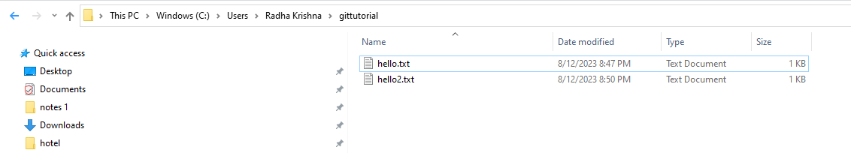

Radha Krishna@LAPTOP-A8SP97KB MINGW64 ~/gittutorial (main)

$ git status

On branch main

Untracked files:

(use "git add <file>..." to include in what will be committed)

hello3.txt

nothing added to commit but untracked files present (use "git add" to track)

Radha Krishna@LAPTOP-A8SP97KB MINGW64 ~/gittutorial (main)

$ git add .

Radha Krishna@LAPTOP-A8SP97KB MINGW64 ~/gittutorial (main)

$ git status

On branch main

Changes to be committed:

(use "git restore --staged <file>..." to unstage)

new file: hello3.txt

Radha Krishna@LAPTOP-A8SP97KB MINGW64 ~/gittutorial (main)

$ git commit -m "Version3 Commited"

[main aa6cc78] Version3 Commited

1 file changed, 3 insertions(+)

create mode 100644 hello3.txt

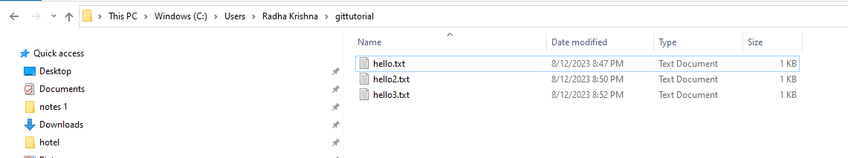

Radha Krishna@LAPTOP-A8SP97KB MINGW64 ~/gittutorial (main)

$ git log --all --graph

* commit aa6cc78f35499e59989d143376a7ba843cda17ef (HEAD -> main)

| Author: Ashmitha <ashmithasumaraj11@gmail.com>

| Date: Sat Aug 12 20:53:24 2023 +0530

|

| Version3 Commited

|

* commit 0baf4355548b0b07a161e7f0cc81c1334bab47c0

| Author: Ashmitha <ashmithasumaraj11@gmail.com>

| Date: Sat Aug 12 20:51:15 2023 +0530

|

| Version2 Commited

|

* commit 136267a28578ced6b3e05615fab9f28b19ea63c0

Author: Ashmitha <ashmithasumaraj11@gmail.com>

Date: Sat Aug 12 20:48:25 2023 +0530

Version1 Commited

**#To create a branch:**

Radha Krishna@LAPTOP-A8SP97KB MINGW64 ~/gittutorial (main)

$ git branch feature1

Radha Krishna@LAPTOP-A8SP97KB MINGW64 ~/gittutorial (main)

$ git log --all --graph

* commit aa6cc78f35499e59989d143376a7ba843cda17ef (HEAD -> main, feature1)

| Author: Ashmitha <ashmithasumaraj11@gmail.com>

| Date: Sat Aug 12 20:53:24 2023 +0530

|

| Version3 Commited

|

* commit 0baf4355548b0b07a161e7f0cc81c1334bab47c0

| Author: Ashmitha <ashmithasumaraj11@gmail.com>

| Date: Sat Aug 12 20:51:15 2023 +0530

|

| Version2 Commited

|

* commit 136267a28578ced6b3e05615fab9f28b19ea63c0

Author: Ashmitha <ashmithasumaraj11@gmail.com>

Date: Sat Aug 12 20:48:25 2023 +0530

Version1 Commited

**#Switching to branch feature1**

Radha Krishna@LAPTOP-A8SP97KB MINGW64 ~/gittutorial (main)

$ git checkout feature1

Switched to branch 'feature1'

Radha Krishna@LAPTOP-A8SP97KB MINGW64 ~/gittutorial (feature1)

**#Create a file feature:**

Radha Krishna@LAPTOP-A8SP97KB MINGW64 ~/gittutorial (feature1)

$ git status

On branch feature1

Untracked files:

(use "git add <file>..." to include in what will be committed)

feature.txt

nothing added to commit but untracked files present (use "git add" to track)

Radha Krishna@LAPTOP-A8SP97KB MINGW64 ~/gittutorial (feature1)

$ git add .

Radha Krishna@LAPTOP-A8SP97KB MINGW64 ~/gittutorial (feature1)

$ git status

On branch feature1

Changes to be committed:

(use "git restore --staged <file>..." to unstage)

new file: feature.txt

Radha Krishna@LAPTOP-A8SP97KB MINGW64 ~/gittutorial (feature1)

$ git commit -m "feature1 Commited"

[feature1 a83b1f5] feature1 Commited

1 file changed, 2 insertions(+)

create mode 100644 feature.txt

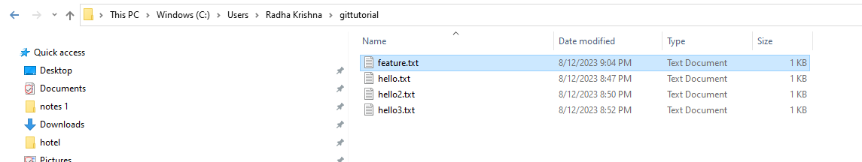

Radha Krishna@LAPTOP-A8SP97KB MINGW64 ~/gittutorial (feature1)

$ git log --all --graph

* commit a83b1f5d3e6eac46350c4b9b42039aaf4ef87f2e (HEAD -> feature1)

| Author: Ashmitha <ashmithasumaraj11@gmail.com>

| Date: Sat Aug 12 21:05:32 2023 +0530

|

| feature1 Commited

|

* commit aa6cc78f35499e59989d143376a7ba843cda17ef (main)

| Author: Ashmitha <ashmithasumaraj11@gmail.com>

| Date: Sat Aug 12 20:53:24 2023 +0530

|

| Version3 Commited

|

* commit 0baf4355548b0b07a161e7f0cc81c1334bab47c0

| Author: Ashmitha <ashmithasumaraj11@gmail.com>

| Date: Sat Aug 12 20:51:15 2023 +0530

|

| Version2 Commited

|

* commit 136267a28578ced6b3e05615fab9f28b19ea63c0

Author: Ashmitha <ashmithasumaraj11@gmail.com>

Date: Sat Aug 12 20:48:25 2023 +0530

Version1 Commited

**#Create a file feature2🡪Type feature2🡪Save it.**

Radha Krishna@LAPTOP-A8SP97KB MINGW64 ~/gittutorial (feature1)

$ git status

On branch feature1

Untracked files:

(use "git add <file>..." to include in what will be committed)

feature2.txt

nothing added to commit but untracked files present (use "git add" to track)

Radha Krishna@LAPTOP-A8SP97KB MINGW64 ~/gittutorial (feature1)

$ git add .

Radha Krishna@LAPTOP-A8SP97KB MINGW64 ~/gittutorial (feature1)

$ git status

On branch feature1

Changes to be committed:

(use "git restore --staged <file>..." to unstage)

new file: feature2.txt

Radha Krishna@LAPTOP-A8SP97KB MINGW64 ~/gittutorial (feature1)

$ git commit -m "feature2 Commited"

[feature1 df254d9] feature2 Commited

1 file changed, 2 insertions(+)

create mode 100644 feature2.txt

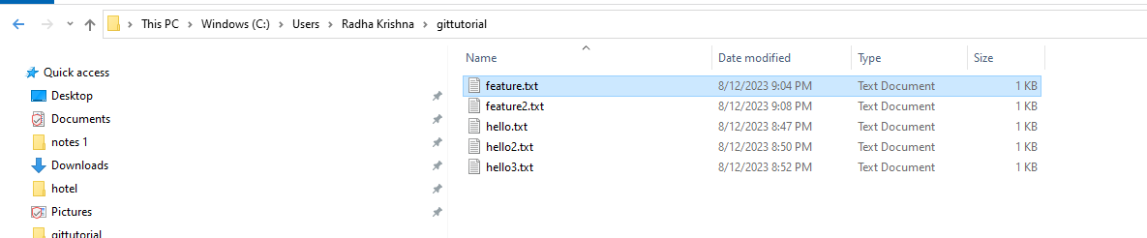

Radha Krishna@LAPTOP-A8SP97KB MINGW64 ~/gittutorial (feature1)

$ git log --all --graph

* commit df254d98e6382cf77a0d94b789068b42d8716885 (HEAD -> feature1)

| Author: Ashmitha <ashmithasumaraj11@gmail.com>

| Date: Sat Aug 12 21:09:41 2023 +0530

|

| feature2 Commited

|

* commit a83b1f5d3e6eac46350c4b9b42039aaf4ef87f2e

| Author: Ashmitha <ashmithasumaraj11@gmail.com>

| Date: Sat Aug 12 21:05:32 2023 +0530

|

| feature1 Commited

|

* commit aa6cc78f35499e59989d143376a7ba843cda17ef (main)

| Author: Ashmitha <ashmithasumaraj11@gmail.com>

| Date: Sat Aug 12 20:53:24 2023 +0530

|

| Version3 Commited

|

* commit 0baf4355548b0b07a161e7f0cc81c1334bab47c0

| Author: Ashmitha <ashmithasumaraj11@gmail.com>

| Date: Sat Aug 12 20:51:15 2023 +0530

**|**

| Version2 Commited

|

* commit 136267a28578ced6b3e05615fab9f28b19ea63c0

Author: Ashmitha <ashmithasumaraj11@gmail.com>

Date: Sat Aug 12 20:48:25 2023 +0530

Version1 Commited

**#Switch between branches:**

Radha Krishna@LAPTOP-A8SP97KB MINGW64 ~/gittutorial (feature1)

$ git checkout main

Switched to branch 'main'

Radha Krishna@LAPTOP-A8SP97KB MINGW64 ~/gittutorial (main)

$ git log --all --graph

* commit df254d98e6382cf77a0d94b789068b42d8716885 (feature1)

| Author: Ashmitha <ashmithasumaraj11@gmail.com>

| Date: Sat Aug 12 21:09:41 2023 +0530

|

| feature2 Commited

|

* commit a83b1f5d3e6eac46350c4b9b42039aaf4ef87f2e

| Author: Ashmitha <ashmithasumaraj11@gmail.com>

| Date: Sat Aug 12 21:05:32 2023 +0530

|

| feature1 Commited

|

* commit aa6cc78f35499e59989d143376a7ba843cda17ef (HEAD -> main)

| Author: Ashmitha <ashmithasumaraj11@gmail.com>

| Date: Sat Aug 12 20:53:24 2023 +0530

|

| Version3 Commited

|

* commit 0baf4355548b0b07a161e7f0cc81c1334bab47c0

| Author: Ashmitha <ashmithasumaraj11@gmail.com>

| Date: Sat Aug 12 20:51:15 2023 +0530

|

| Version2 Commited

|

* commit 136267a28578ced6b3e05615fab9f28b19ea63c0

Author: Ashmitha <ashmithasumaraj11@gmail.com>

Date: Sat Aug 12 20:48:25 2023 +0530

Version1 Commited

**Merging**

**#Go back to feature1:**

Radha Krishna@LAPTOP-A8SP97KB MINGW64 ~/gittutorial (main)

$ git checkout feature1

Switched to branch 'feature1'

Radha Krishna@LAPTOP-A8SP97KB MINGW64 ~/gittutorial (feature1)

$ git log --all --graph

* commit df254d98e6382cf77a0d94b789068b42d8716885 (HEAD -> feature1)

| Author: Ashmitha <ashmithasumaraj11@gmail.com>

| Date: Sat Aug 12 21:09:41 2023 +0530

|

| feature2 Commited

|

* commit a83b1f5d3e6eac46350c4b9b42039aaf4ef87f2e

| Author: Ashmitha <ashmithasumaraj11@gmail.com>

| Date: Sat Aug 12 21:05:32 2023 +0530

|

| feature1 Commited

|

* commit aa6cc78f35499e59989d143376a7ba843cda17ef (main)

| Author: Ashmitha <ashmithasumaraj11@gmail.com>

| Date: Sat Aug 12 20:53:24 2023 +0530

|

| Version3 Commited

|

* commit 0baf4355548b0b07a161e7f0cc81c1334bab47c0

| Author: Ashmitha <ashmithasumaraj11@gmail.com>

| Date: Sat Aug 12 20:51:15 2023 +0530

|

| Version2 Commited

|

* commit 136267a28578ced6b3e05615fab9f28b19ea63c0

Author: Ashmitha <ashmithasumaraj11@gmail.com>

Date: Sat Aug 12 20:48:25 2023 +0530

Version1 Commited

**#Delete hello file from main branch and create file bugfix**

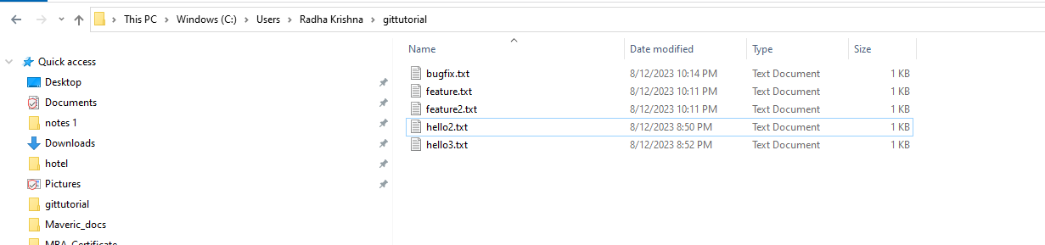

Radha Krishna@LAPTOP-A8SP97KB MINGW64 ~/gittutorial (feature1)

$ git status

On branch feature1

Changes not staged for commit:

(use "git add/rm <file>..." to update what will be committed)

(use "git restore <file>..." to discard changes in working directory)

deleted: hello.txt

Untracked files:

(use "git add <file>..." to include in what will be committed)

bugfix.txt

no changes added to commit (use "git add" and/or "git commit -a")

Radha Krishna@LAPTOP-A8SP97KB MINGW64 ~/gittutorial (feature1)

$ git add .

Radha Krishna@LAPTOP-A8SP97KB MINGW64 ~/gittutorial (feature1)

$ git status

On branch feature1

Changes to be committed:

(use "git restore --staged <file>..." to unstage)

new file: bugfix.txt

deleted: hello.txt

Radha Krishna@LAPTOP-A8SP97KB MINGW64 ~/gittutorial (feature1)

$ git checkout main

Switched to branch 'main'

A bugfix.txt

D hello.txt

Radha Krishna@LAPTOP-A8SP97KB MINGW64 ~/gittutorial (main)

$ git status

On branch main

Changes to be committed:

(use "git restore --staged <file>..." to unstage)

new file: bugfix.txt

deleted: hello.txt

Radha Krishna@LAPTOP-A8SP97KB MINGW64 ~/gittutorial (main)

$ git log --all --graph

* commit df254d98e6382cf77a0d94b789068b42d8716885 (feature1)

| Author: Ashmitha <ashmithasumaraj11@gmail.com>

| Date: Sat Aug 12 21:09:41 2023 +0530

|

| feature2 Commited

|

* commit a83b1f5d3e6eac46350c4b9b42039aaf4ef87f2e

| Author: Ashmitha <ashmithasumaraj11@gmail.com>

| Date: Sat Aug 12 21:05:32 2023 +0530

|

| feature1 Commited

|

* commit aa6cc78f35499e59989d143376a7ba843cda17ef (HEAD -> main)

| Author: Ashmitha <ashmithasumaraj11@gmail.com>

| Date: Sat Aug 12 20:53:24 2023 +0530

|

| Version3 Commited

|

* commit 0baf4355548b0b07a161e7f0cc81c1334bab47c0

| Author: Ashmitha <ashmithasumaraj11@gmail.com>

| Date: Sat Aug 12 20:51:15 2023 +0530

|

| Version2 Commited

|

* commit 136267a28578ced6b3e05615fab9f28b19ea63c0

Author: Ashmitha <ashmithasumaraj11@gmail.com>

Date: Sat Aug 12 20:48:25 2023 +0530

Version1 Commited

**#Go to feature file🡪Type “Commit feature3”**

Radha Krishna@LAPTOP-A8SP97KB MINGW64 ~/gittutorial (feature1)

$ git status

On branch feature1

Changes to be committed:

(use "git restore --staged <file>..." to unstage)

new file: bugfix.txt

deleted: hello.txt

Untracked files:

(use "git add <file>..." to include in what will be committed)

feature3.txt

Radha Krishna@LAPTOP-A8SP97KB MINGW64 ~/gittutorial (feature1)

$ git add .

Radha Krishna@LAPTOP-A8SP97KB MINGW64 ~/gittutorial (feature1)

$ git status

On branch feature1

Changes to be committed:

(use "git restore --staged <file>..." to unstage)

new file: bugfix.txt

new file: feature3.txt

deleted: hello.txt

Radha Krishna@LAPTOP-A8SP97KB MINGW64 ~/gittutorial (feature1)

$ git commit -m "feature3 Commited"

[feature1 3295006] feature3 Commited

3 files changed, 5 insertions(+), 3 deletions(-)

create mode 100644 bugfix.txt

create mode 100644 feature3.txt

delete mode 100644 hello.txt

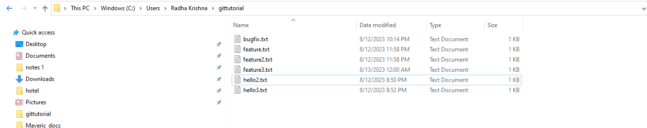

**#Switch to master branch**

Radha Krishna@LAPTOP-A8SP97KB MINGW64 ~/gittutorial (feature1)

$ git checkout main

Switched to branch 'main'

Radha Krishna@LAPTOP-A8SP97KB MINGW64 ~/gittutorial (main)

$ git log --all --graph

* commit 3295006390b31176b618ea1fb5381ee9f58689a4 (feature1)

| Author: Ashmitha <ashmithasumaraj11@gmail.com>

| Date: Sun Aug 13 00:01:42 2023 +0530

|

| feature3 Commited

|

* commit df254d98e6382cf77a0d94b789068b42d8716885

| Author: Ashmitha <ashmithasumaraj11@gmail.com>

| Date: Sat Aug 12 21:09:41 2023 +0530

|

| feature2 Commited

|

* commit a83b1f5d3e6eac46350c4b9b42039aaf4ef87f2e

| Author: Ashmitha <ashmithasumaraj11@gmail.com>

| Date: Sat Aug 12 21:05:32 2023 +0530

|

| feature1 Commited

|

* commit aa6cc78f35499e59989d143376a7ba843cda17ef (HEAD -> main)

| Author: Ashmitha <ashmithasumaraj11@gmail.com>

| Date: Sat Aug 12 20:53:24 2023 +0530

|

| Version3 Commited

|

* commit 0baf4355548b0b07a161e7f0cc81c1334bab47c0

| Author: Ashmitha <ashmithasumaraj11@gmail.com>

| Date: Sat Aug 12 20:51:15 2023 +0530

|

| Version2 Commited

|

* commit 136267a28578ced6b3e05615fab9f28b19ea63c0

Author: Ashmitha <ashmithasumaraj11@gmail.com>

Date: Sat Aug 12 20:48:25 2023 +0530

Version1 Commited

Radha Krishna@LAPTOP-A8SP97KB MINGW64 ~/gittutorial (main)

$ git merge feature1 -m "Merge feature1"

Updating aa6cc78..3295006

Fast-forward (no commit created; -m option ignored)

bugfix.txt | 2 ++

feature.txt | 2 ++

feature2.txt | 2 ++

feature3.txt | 3 +++

hello.txt | 3 ---

5 files changed, 9 insertions(+), 3 deletions(-)

create mode 100644 bugfix.txt

create mode 100644 feature.txt

create mode 100644 feature2.txt

create mode 100644 feature3.txt

delete mode 100644 hello.txt

Radha Krishna@LAPTOP-A8SP97KB MINGW64 ~/gittutorial (main)

$ git log --all --graph

* commit 3295006390b31176b618ea1fb5381ee9f58689a4 (HEAD -> main, feature1)

| Author: Ashmitha <ashmithasumaraj11@gmail.com>

| Date: Sun Aug 13 00:01:42 2023 +0530

|

| feature3 Commited

|

* commit df254d98e6382cf77a0d94b789068b42d8716885

| Author: Ashmitha <ashmithasumaraj11@gmail.com>

| Date: Sat Aug 12 21:09:41 2023 +0530

|

| feature2 Commited

|

* commit a83b1f5d3e6eac46350c4b9b42039aaf4ef87f2e

| Author: Ashmitha <ashmithasumaraj11@gmail.com>

| Date: Sat Aug 12 21:05:32 2023 +0530

|

| feature1 Commited

|

* commit aa6cc78f35499e59989d143376a7ba843cda17ef

| Author: Ashmitha <ashmithasumaraj11@gmail.com>

| Date: Sat Aug 12 20:53:24 2023 +0530

|

| Version3 Commited

|

* commit 0baf4355548b0b07a161e7f0cc81c1334bab47c0

| Author: Ashmitha <ashmithasumaraj11@gmail.com>

| Date: Sat Aug 12 20:51:15 2023 +0530

|

| Version2 Commited

|

* commit 136267a28578ced6b3e05615fab9f28b19ea63c0

Author: Ashmitha <ashmithasumaraj11@gmail.com>

Date: Sat Aug 12 20:48:25 2023 +0530

Version1 Commited